Minikube version and minikube dashboard

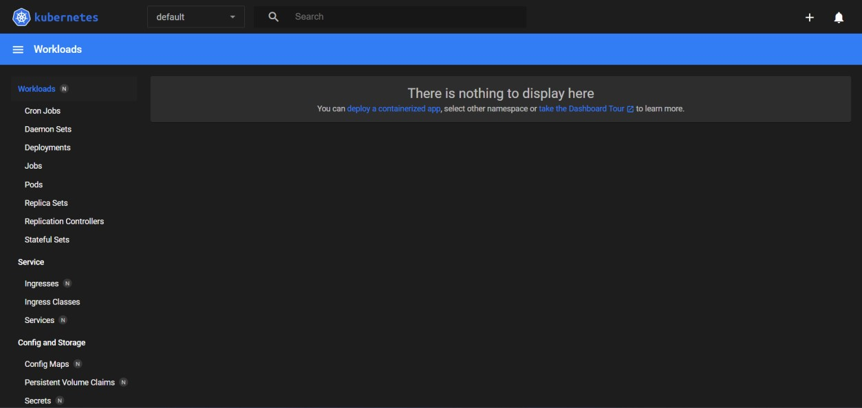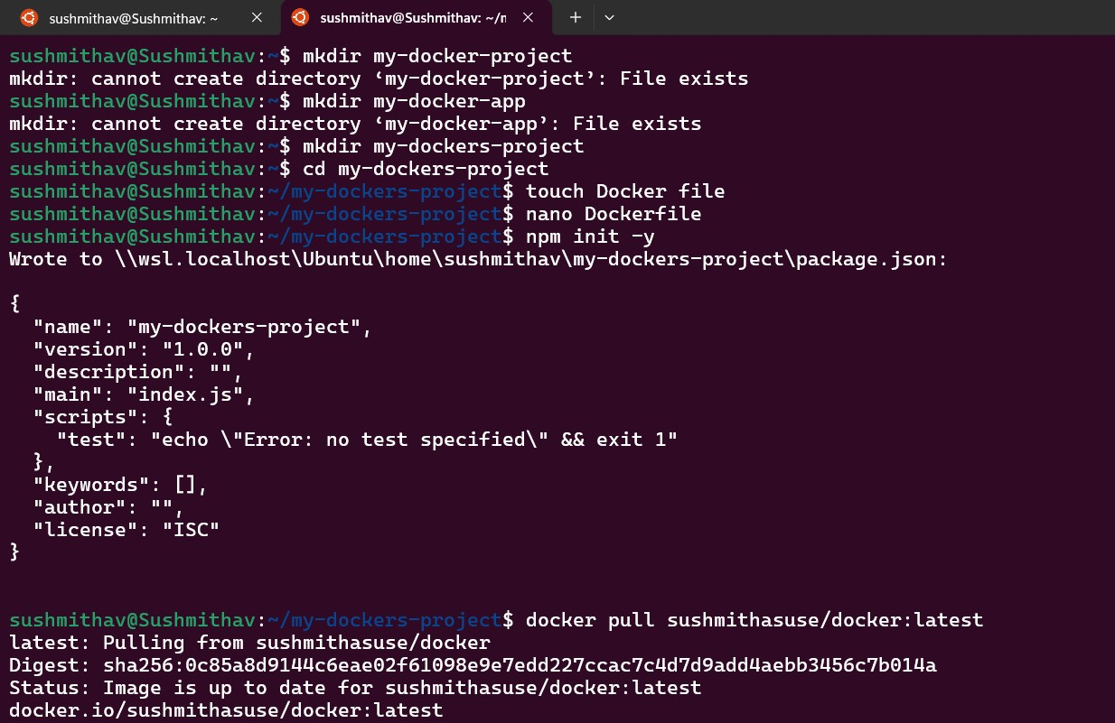

Docker build -t sushmithasuse/docker:latest

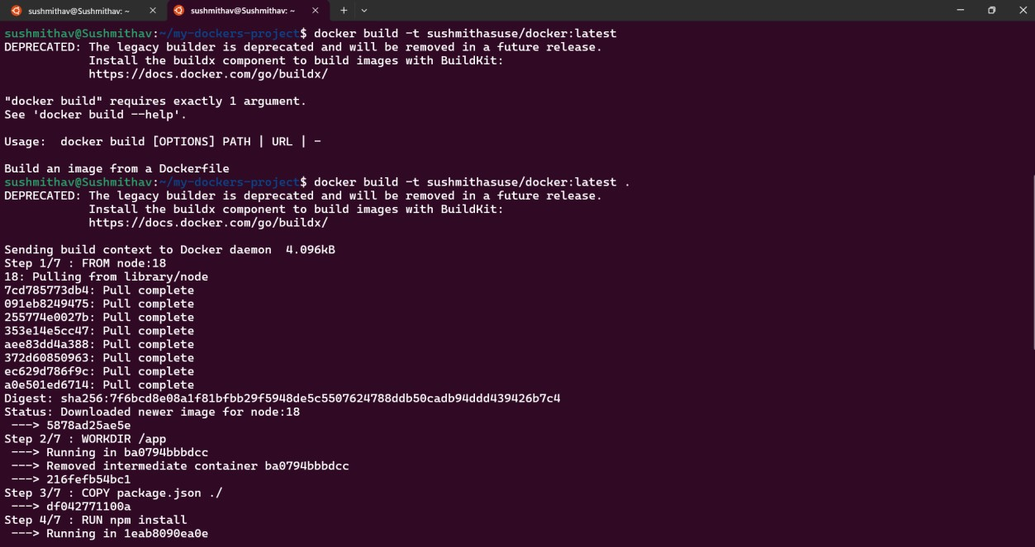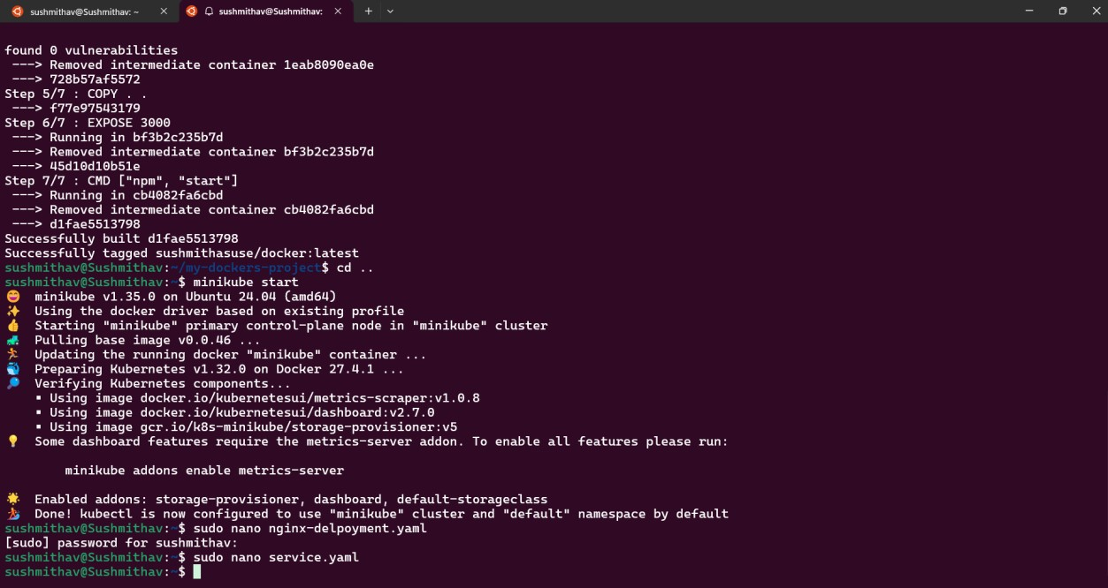

kubectl apply -f nginx-deployement

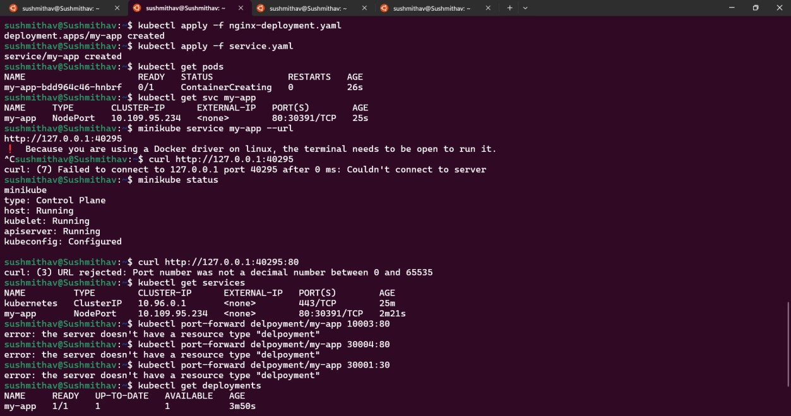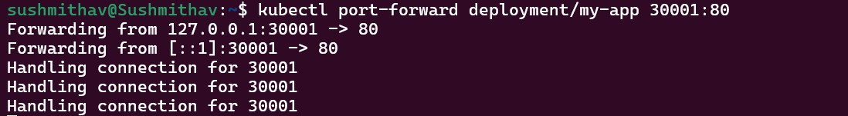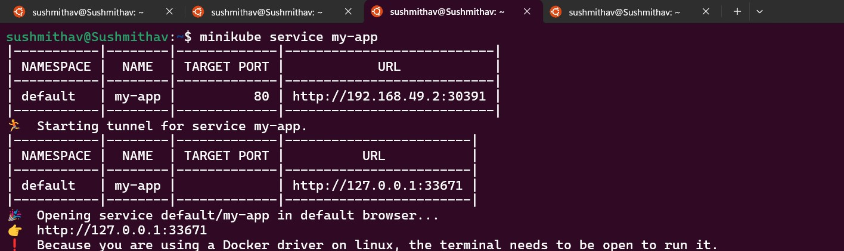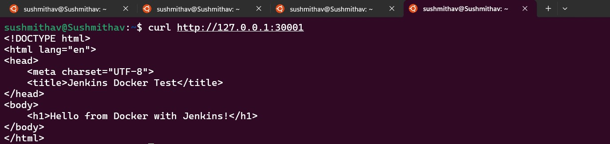

TASK 3 MINIKUBE

Minikube output:Hello from Docker with jenkins

